Improving typhoon forecast with uncertainty quantification

Mengwei Li, Qingyun Duan, Zhenhua Di

College of Global Change and Earth System Science, Beijing Normal University

Correspondence to: limengwei@bnu.edu.com.cn

## Abstract

For decades, severe weather systems typhoon have caused [uncountable](http://dict.youdao.com/w/uncountable/" \l "keyfrom=E2Ctranslation) loss on casualties and properties in hitting areas worldwide, especially for concentrated urbanized countries like China. However, predicting typhoon considerably suffers from uncertainties including model physics and initial condition. To iron out such adverseness, in our experiment, we performed a whole set of Uncertainty Quantification (UQ) procedure including scoping out parameter, sampling, sensitivity analysis and optimization questing for a better parameter set to improve model performance. Further, we transfer this optimum to several other analogous typhoon events to validate its effectiveness and robustness.

The result shows that for most cases, the model outperforms than before not just on target case but also on validation cases in many aspects including precipitation and typhoon intensity. Thus such UQ solution have demonstrated its effect and provided researchers a promising way optimizing large complex model by parameter specification to ensure better forecast. Moreover, this endeavor is also a good news for operational typhoon prediction since it tries to follow suit of [China Meteorological Administration](http://dict.youdao.com/w/China%20Meteorological%20Administration/" \l "keyfrom=E2Ctranslation) (CMA) in terms of model warm up procedure as well as model settings which means it can be easy readily to put into practice.

## Introduction

Every year, many places in the world suffer from nature's most deadly power, storm. Such catastrophic weather events are probably the most devastating disasters humankind ever faced. Typhoon outweighed other disasters like earthquakes, volcanic eruptions in terms of frequency and often induce severe secondary disasters like storm surges and floods [Almanac article: Fact Monster.© 2000–2013 Sandbox Networks, Inc., publishing as Fact Monster.01 Nov. 2016 http://www.factmonster.com/ipka/A0775896.html]. When landfall takes place in urban area it would cause the most devastating damage. They are able to topple trees, down power lines, and killing anyone in its path. Often they leave in their wake a trail of injury, death, loss of livestock, property damage and economic loss. China is ranked one of the most severe typhoon affected countries especially where there are long and rich coastlines near the Southeast Asia region, with over 10,000 casualties and over US$2500 million economic losses annually on average. [Recent studies on tropical cyclone land falling in China; Lei Xiaotu, Shanghai Typhoon Institute CMA, Shanghai, China]. According to statistics at CMA, merely the number of landfilling can reaches 8 to 10 times according to statistics each year in China. The impact is self-evident.

Though such extreme event is devastating, it is in one of the few disasters that give people lead time, thus we can plan things until the storm really hits -- gather supplies, suspend civil liberties or evacuation if necessary. With the state of the art technology, scientists and experts can nowadays speculate the date and time even the place where storm will strike with the help of numerical model like WRF. But what to do next? Should residents all evacuated from their homeland and later proved to be unnecessary? Or should we keep going out for shopping then ended up blowing away by brutal wind? Should water departments vacuum up their reservoirs to be prepared for a coming pouring rain? An accurate prediction of typhoon intensity and other attributes is the only key to these problems. If numerical models always work fine, theoretically, we can always be set of pertinent preparedness ahead, in areas that are potentially threatened.

And that is why the main purpose of this essay focuses on the second issue, forecasting, trying our way through to find an effective way better utilizing complex numerical forecasting typhoon. The problem is however, numerical model keeps sufferingnjop from three main flaws that compromise its forecast: 1) model error; 2) data error and 3) parameter error summarized by Duan in 2006[Duan, Q., Schaake, J., Andreassian, V., Franks, S., Goteti, G., Gupta, H.V., Gusev, Y.M.,Habets, F., Hall, A., Hay, L., Hogue, T., Huang, M., Leavesley, G., Liang, X.,Nasonova, O.N., Noilhan, J., Oudin, L., Sorooshian, S., Wagener, T., Wood, E.F.,2006. Model parameter estimation experiment (MOPEX): an overview of science strategy and major results from the second and third workshops. J. Hydrol.320 (1e2), 3e17], which respectively refers to 1) model structure insufficiency; 2) initial/boundary conditions inaccuracy and 3) model parameters uncertainty. When it comes to large physical models which could takes hours for a single forward run, these defects are increasingly fierce, making the improvement in numerical typhoon forecasting represents one of the greatest challenges in numerical weather prediction (NWP).[ Chun-Chieh Wu, Morris A. Bender and Yoshio Kuriharal, Typhoon Forecast with the GFDL Hurricane Model: Forecast Skill and Comparison of Predictions- using AVN and NOGAPS Global Analyses, Journal 01 Meteorological Society 01 Japan, Vol. 78, No.6, pp. 777-788, 2000]

In fact, researchers have tried hard to find a way to do better forecast over typhoon. Preliminary, the pursuits are around to eliminate three above mentioned compromising factors:

First, to improve the structure of model forecasting typhoon, efforts have been made by Emanuel in 2003, [Emanuel, K. A., 2003: Asimilarity hypothesis for air–sea exchange at extreme wind speeds. J. Atmos. Sci., 60, 1420–1428.]Donelan et al. and Moon [Moon, I.-J., I. Ginis, and T. Hara, 2004: Effect of surface waves on Charnock coefficient under tropical cyclones. Geophys. Res. Lett., 31, L20302, doi:10.1029/2004GL020988.] in 2004 as they all attempted to refine the physical process of model by exploring the sea surface water heat flux mechanism that impact local Atmospheric Motion. Davis et al. [Davis, C., and Coauthors, 2008: Prediction of landfalling hurricanes with the Advanced Hurricane WRF model. Mon. Wea. Rev., 136, 1990–2005.]have studied local air-sea interaction based on the impacts of ocean sea surface feedback processes for TC development, Ma [Ma, L.-M., and Z.-M. Tan, 2009: Improving the behavior of the cumulus parameterization for tropical cyclone prediction: Convection trigger. Atmos. Res., 92, 190–211.]and Tan in 2009 modified a new convective parameterization scheme for modellers to choose, yet Chen et al. in 2007 [Chen, S. S., J. F. Price, W. Zhao, M. A. Donelan, and E. J. Walsh, 2007: The CBLAST-Hurricane Program and the next-generation fully coupled atmosphere–wave–ocean models for hurricane research and prediction. Bull. Amer. Meteor. Soc., 88, 311–317.]have focused on model resolution setup affecting model performance. Second, to obtain better initial condition, various initialization methods have been employed. Ueno in 1989[Ueno, M., 1989: Operational bogussing and numerical prediction of typhoon in JMA. JMA/NPD Tech. Rep. 28, 48 pp.], Davis and Nam in 2001 all have proved that the use of analytic empirical functions to generate synthetic or bogus( bogus is a mathematical model simulating intensity-vortex system) vortex for surface pressure and wind to replace the vortex in the analysis can warm up the initial model condition. Scientists like George, Jeffries in 1994 [George, J. S., and R. A. Jeffries, 1994: Assimilation of synthetic tropical cyclone observations into the Navy Operational Global Atmospheric Prediction System. Wea. Forecasting, 9, 557–576.]and others in later year [Zou, X., and Q. Xiao, 2000: Studies on the initialization and simulation of a mature hurricane using a variational bogus data assimilation scheme. J. Atmos. Sci., 57, 836–860][ Davidson,N.E., andH.C.Weber, 2000: TheBMRChigh-resolution tropical cyclone prediction system: TC-LAPS. Mon. Wea. Rev., 128, 1245–1265.]has employed synthetic data assimilation (known as BDA) approach which uses variational data assimilation with synthetic observations of a TC vortex that closely matches the observed TC intensity and structure. Kurihara et al. in 1993[Kurihara, Y., M. A. Bender, and R. J. Ross, 1993: An initialization scheme of hurricane models by vortex specification. Mon. Wea. Rev., 121, 2030–2045.], proposed an axisymmetric vortex generation initialization method, then similar method was used in the U.S. Navy regional coupled model for TC prediction by Hendricks et al. in 2011[Hendricks, E. A., M. S. Peng, X. Ge, and T. Li, 2011: Performance of a dynamic initialization scheme in the Coupled Ocean–Atmosphere Mesoscale Prediction System for Tropical Cyclones (COAMPS-TC). Wea. Forecasting, 26, 650–663.]. When modeling a typhoon, it is of great significance having such warm up process to the model. The third is to refine model parameter specifications during typhoon forecast. Former research paid little attention to this field. There are studies of tuning parameters in runoff models like sacramento model[Sorooshian S, Duan Q, Gupta V K. Calibration of rainfall‐runoff models: Application of global optimization to the Sacramento Soil Moisture Accounting Model[J]. Water Resources Research, 1993, 29(4):1185–1194.], and there are also studies that tries to optimize parameter over inland rainfall[Gilmore M S, Straka J M, Rasmussen E N. Precipitation Uncertainty Due to Variations in Precipitation Particle Parameters within a Simple Microphysics Scheme[J]. Monthly Weather Review, 2004, 132(11):2610.], but relevant research is rare as for typhoon forecast. Yet it is still neccessary for us to look deeper into this issue as “an unmerited or erroneous parameter specification, especially for dominate ones would have significant influence on model performance” [Duan, Q.Y., Sorooshian, S., Gupta, V., 1992. Effective and efficient global optimization for conceptual rainfall-runoff models. Water Resour. Res. 28 (4), 1015e1031.].

For three flaws mentioned above, in this study, we employee WRF version 3.7 meeting ends of favorable model structure and model robustness to deal with first flaw; a productive WRF module called Dynamical Initialization (DI) to spin up model condition dealing with the second; and a whole set of uncertainty quantification (UQ) procedure for parameter calibration with the last. We expect a better typhoon prediction in terms of many aspect we may consider in practice: intensity, which could be measured by pressure and wind speed, precipitation, which could be measure by TS or accumulated amount.

This paper is arranged as follows: Section 1 above gave out an introduction of typhoon forecast using numerical model, its background, state of art and existing problem. Section 2 below will depict relevant methodology we use optimizing such problem. Section 3 is a case study of typhoon Rumbia (NO.1306) with detailed information about model settings, warm up and specific UQ implementation. Section 4 shows the result of target case optimization and we then after authenticate the its effectiveness by transfer it to other four validation cases. At last, section 5 there are summary of conclusions and further discussion.

## Methodology: Uncertainty Quantification (UQ)

To reduce the impact of parameter specification ambiguity, we undertook a whole set of uncertainty quantification (UQ) procedure. This procedure contains key steps used in many fields of engineering and geophysics, sensitivity analysis and optimization, to assess and predict the likelihood of various outcomes. [A GUI platform for uncertainty quantification of complex dynamical models,2015,Chen Wang, QingYun Duan, Environmental Modelling & Software 76 (2016) 1e12] . It is an expected way to quantitatively characterize and reduce uncertainties that show up in experiments. Particularly for computer models, this uncertainty attribute to parameter uncertainty. However, parameter specification is complicated by the fact that today’s geophysical models consider an increasing number of physical processes (water/energy cycles, biogeochemical processes etc.) that induce loads of parameters and dramatically increase the dimension of problem. Without a series of systematic approach such problem can be too expensive to solve for computing resources.

Rigorously perform a whole set of UQ from scratch can be of great workload, including (Fig1 below): 1)characterize the uncertainty sources for a given problem, 2)set up the experimental design to implement proper sampling (which includes identifying their range and distributions), 3)screen out sensitive parameters when dimension of problem is high [Multi-objective parameter optimization of CLM using adaptive surrogate modeling, 2015, W.Gong, Q.Duan], 4)construct surrogate/meta model as substitute if forward model is time consuming, 5)implement proper optimization algorithm to gain desired outcome and test its accountability etc. Fortunately, making use of our previous developed software “UQ-PyL” specially designed for all kinds of model uncertainty analysis to perform such footages is quite easy. [A GUI platform for uncertainty quantification of complex dynamical Models,2015, Chen Wang, Qingyun Duan, Environmental Modelling & Software 76 (2016) 1e12].

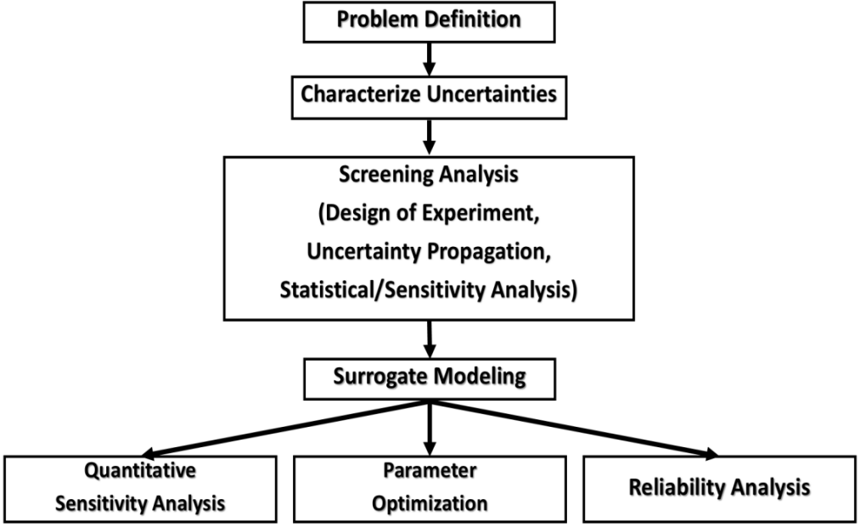

Fig1. Key steps of UQ included in UQ-PyL

(Cited from A GUI platform for uncertainty quantification of complex dynamical models, EMS, Chen Wang and Qingyun Duan)

Above Fig1 also shows our sequence undertaking UQ in this study.

Specifically, our objective in step1 ‘problem definition’ is to improve typhoon prediction by WRF. In step2, as there are seven scheme that mainly controls the action of model, from which we scope out 23 time invariant adjustable parameters influencing on output and grant them a disturbance band for later calibration. This procedure primarily depends on general understanding of the model and reviewing previous studies[Assessing WRF model parameter sensitivity: A case study with 5 day summer precipitation forecasting in the Greater Beijing Area, 2014, Zhenhua Di], as well as consulting experts or founder of certain module. Further details their sources, physical meanings, ranges are listed below in List1.

|  |  |  |  |  |  |
| --- | --- | --- | --- | --- | --- |
| ***Index*** | ***Scheme (Source file)*** | ***Parameter*** | ***Default*** | ***Range*** | ***Description*** |
| ***No.1*** | *Surface layer*  *(module_sf_sfclay.F)* | *Xka* | *2.4e-5* | *[1.2e-5 5e-5]* | *The parameter for heat/moisture exchange coefficient(s m-2)* |
| ***No.2*** | *Czo* | *0.0185* | *[0.01 0.037]* | *The coefficient for converting wind speed to roughness length over water* |
| ***No.3*** | *Cumulus*  *(module_cu_kfeta.F)* | *Pd* | *None* | *[-1 1]* | *The multiplier for downdraft mass flux rate* |
| ***No.4*** | *Pe* | *None* | *[-1 1]* | *The multiplier for entrainment mass flux rate* |
| ***No.5*** | *Ph* | *150* | *[50 350]* | *Starting height of downdraft above USL(hPa)* |
| ***No.6*** | *TIMEC* | *2400* | *[1800 3600]* | *Average consumption time of CAPE(s)* |
| ***No.7*** | *TKEMAX* | *5* | *[3 12]* | *The maximum turbulent kinetic energy (TKE) value*  *in sub-cloud layer(m2 s-2)* |
| ***No.8*** | *Microphysics*  *(module_mp_wsm6.F)* | *ice_stokes_fac* | *14900* | *[8000 30000]* | *Scaling factor applied to ice fall velocity(s-1)* |
| ***No.9*** | *n0r* | *8e+6* | *[5e+6 1.2e+7]* | *Intercept parameter of rain(m-4)* |
| ***No.10*** | *dimax* | *5e-4* | *[3e-4 8e-4]* | *The limited maximum value for the cloud-ice diameter(m)* |
| ***No.11*** | *peaut* | *0.55* | *[0.35 0.85]* | *Collection efficiency from cloud to rain auto conversion* |
| ***No.12*** | *Short Wave Radiation*  *(module_ra_sw.F)* | *cssca* | *1e-5* | *[5e-6 2e-5]* | *Scattering tuning parameter (m2 kg-1)* |
| ***No.13*** | *beta_P* | *0.4* | *[0.2 0.8]* | *Multiplier for clear-sky aerosol scattering effect* |
| ***No.14*** | *Longwave*  *(module_ra_rrtm.F)* | *secang* | *1.66* | *[1.55 1.75]* | *Diffusivity angle for cloud optical depth computation* |
| ***No.15*** | *Planetary Boundary Layer*  *(module_bl_ysu.F)* | *brcr_sbrob* | *0.3* | *[0.15 0.6]* | *Critical Richardson number for boundary layer of water* |
| ***No.16*** | *brcr_sb* | *0.25* | *[0.125 0.5]* | *Critical Richardson number for boundary layer of land* |
| ***No.17*** | *pfac* | *2* | *[1 3]* | *Profile shape exponent for calculating the*  *momentum diffusivity coefficient* |
| ***No.18*** | *bfac* | *6.8* | *[3.4 13.6]* | *Coefficient for prandtl number at the top of the surface layer* |
| ***No.19*** | *Sm* | *15.9* | *[12 20]* | *Counter gradient proportional coefficient of non-local flux of momentum* |
| ***No.20*** | *Land Surface*  *(module_sf_noahlsm.F)* | *DSATDK* | *0* | *[-1 1]* | *The multiplier for hydraulic conductivity at saturation* | |
| ***No.21*** | *DMAXSMC* | *0* | *[-1 1]* | *The multiplier for the saturated soil water content* | |
| ***No.22*** | *DSATPSI* | *0* | *[-1 1]* | *The multiplier for minimum soil suction* | |
| ***No.23*** | *DBB* | *0* | *[-1 1]* | *The multiplier for Clapp and hornbereger "b" parameter* | |

List1. The range, and interpretation of parameters selected

For step3, there are few more child steps within Design of Experiment (DoE). First is sampling. We first adopt quansi-monte-carlo (QMC) method sampling over these parameters (which ensures a good space-filling capability and recommended by former studies). We took total sampling time of 250, as recommended in previous study of JD.Li, which suggests that for our problem dimension, sampling time about 10 times the dimension should be able to balance efficiency of computation and effectiveness of grasp of model dynamics.**. [**Assessing parameter importance of the Common Land Model based on qualitative and quantitative sensitivity analysis, J.Li, Q.Y.Duan, Hess, doi: 10.5194/hess 17-3279-2013**]** Note that besides these 23 parameters, all other types of data like boundary forcing, assimilation data, or any other internal variables (number of grid points for example) we fed into model are consistent---they are not allowed to vary thus they cannot contribute to any variation in the output.

Also in step3 above, we quantified their sensitivity. Sensitivity analysis (SA) defines of how uncertainties in model output is proportioned the input variation. To achieve this, we proposed a few objective functions, all their expressions, physical meanings and purposes, are listed in below List2. Additionally, the outcome of their sensitivity results are base on comprehensive result of multiple analysis methods, including multivariate adaptive regression spline (MARS), sum of tree (SOT), delta-test (DT) and surrogate-based Sobol. That is to say, for each given objective, we conducted sensitivity based on different methods. Thus, the cumulative significance S of parameters i can be computed as:

 (1)

where C_mn is the sensitivity vector of 23 parameter evaluated by method m considering objective j, f_N0-1 performs 0-1 normalization over methods where 1 represent most sensitive, 0 to least sensitive. The cumulative significance denoted as S_i is computed as average over number of objectives N times number of SA methods M.

|  |  |  |  |  |
| --- | --- | --- | --- | --- |
| ***Objective name*** | ***Expression*** | ***Representation*** | ***Physical meaning*** | ***Purpose setting this value*** |
| ***Total Precipitation Amount***  ***(for rainfall)*** |  | *I---total number of grid points*  *T---total number of time step*  *P---precipitation each grid point precipitant* | *Overall amount of precipitation over entire area.* | *The purpose setting this as one of target function is because overestimate the precipitation has long been a common flaw of typhoon forecast. This will accumulate over time giving us a clear sight of total precipitation amount.* |
| ***Weighted Thread Score***  ***(for rainfall)*** |  | *NA/NB/NC---the case of Hit/Miss/False event when forecast a certain type of rain*  *Types---classified types according to TS general rule by precipitation per hour.*  *W---weight of each type of rain given by area proportion* | *The correctness of predicting a certain type of rain.* | *The value of TS ranges from 0 at the poor end to 1 at the good end and has widely been used in practice to judge if the prediction is good or not. Have Optimizing this value near to 1 would give positive effect when predicting rainfall.* |
| ***Mean Absolute Error（MAE）***  ***(for wind speed and pressure)*** |  | *Mod_P---predict value of a perturbed model*  *Mod_D---default model result*  *I---number of total grid point*  *T---number of total time* | *System errors predicting wind/pressure* | *MAE is commonly used to represent system errors giving equal weight over regions. Optimizing this value to minimum will gain positive effect.* |
| ***Structure-Amplitude-Location (SAL) score***  ***(for rainfall)*** |  | *Rp---mass center of perturbed model output precipitation*  *Rd---Mass center of default output precipitation*  *S---measurement of rainfall Structure*  *A---measurement of amplitude*  *L---measurement of location* | *This approach evaluate the spatial form between rainfall events. For detials refer to [SAL—A Novel Quality Measure for the Verification of Quantitative Precipitation Forecasts, Heini Wernli and Marcus Paulat, Monthly Weather Review, Vol 136, 2008]* | *The closer the SAL value to zero, the more two rainfall matches. The extent of their agreement serves as a important index judging sensitivity of different parameter set.* |
| ***Determination coefficient***  ***(for wind speed and pressure)*** |  | *Yi---default model result*  *Yf---forecast value of a perturbed model* | *Coefficient of determination is square of correlation coefficient* | *Indicates the proportion of the variance in the dependent variable that is predictable from the independent variable. It provides a measurement of how well observed outcomes are replicated by the model, based on the proportion of total variation of outcomes explained by the model.* |
| ***Root Mean Square Error (RMSE)***  ***(for rainfall, wind speed and pressure)*** |  | *Mod_P---predict value of a perturbed model*  *Mod_D---default model result*  *I---number of total grid point*  *T---number of total time* | *System errors predicting rain/wind/pressure* | *Similar to MAE but gives more weight to area where there are large errors and makes it most useful when large errors are particularly undesirable.* |
| ***Force-10 Wind Radius (F10R)***  ***(for wind speed)*** |  | *Lf10---location at where wind speed range Beaufort scale level 10*  *Lc---center location of typhoon* | *The area within radius would at least experience level 10 wind blow* | *The radius standard is used in practice and by operational organization, assessing where and how the typhoon would have impact on. Specify this value to check parameter sensitivity over typhoon radius.* |

List2. Objective functions and description for sensitivity analysis

Next in step4, as for WRF model, since a single model forward will take hours of CPU, it will be very expensive to do all computation on original model for optimization algorithm , thus we build surrogate (or meta) model based on Gaussian Process Regression (GPR). GPR is one of machine learning methods. It is based on statistical learning theory and Bayesian theory, and it’s perfectly suit for this high-dimensional yet small-sampling problems with nonlinear regression. [Rasmussen, C. E. and Williams, C. K. I.: Gaussian Processes for Machine Learning, MIT Press, Massachusetts, USA, 2006.]

In final step5, based on several top sensitive parameters previously screened out, we improve search speed during optimization by adaptive surrogates modeling optimization (ASMO) method. Briefly, in ASMO optimization algorithm, it uses a surrogate model per epoch which is constructed by adaptive sampling to represent the input-output response of the original simulation model. [Wang C, Duan Q, Gong W, et al. An evaluation of adaptive surrogate modeling based optimization with two benchmark problems[J]. Environmental Modelling & Software, 2014, 60(76):167-179.] In our experiment, we built up initial surrogates with 200 sample run on dominant parameters selected. At each epoch, there will be a newly sampled point (or points), and corresponding value from simulation to refine response surface to make it more accurate.

The chose of objective function (lose/energy function) is also very important. Note that the objectives we use here could differ from what we used in SA processes. To ensure our optimization result more tangible for practical use, our final objective function is composed of several widely concerning criterion evaluating typhoon forecast skill. Specifically, we chose four criterion: 1) maximum wind speed MAE, 2) center pressure MAE, 3) rainfall Thread Score (TS, in practical use we use negative TS to have its optimize direction coherent with other criterion’s) and 4) 6-hourly precipitation amount error. In order to transform multi-objective problem into single-objective problem, four criterion are equally weighted after normalization before they serve as our final objective function. Assumes that f_z(v_s) performs Z-score function to vector v_s where v_s is evaluated value over criterion s, and number of criterion denoted as N. Then final objective y can be given as:

 (2)

## Experimental Design

### Model settings

Late June and early July in 2013, typhoon Rumbia comes ashore in China. She wiped the coast of Guangdong striking a serious punch, and crippled entire communities. Rumbia continued strengthening over open water, and reached its peak intensity. Heavy rain and high winds rattled the sky and kicked up mountainous wave at ocean. Flood water surged over the levees and gulfed the city. Though no death toll reported, merely across Guangdong Zhanjiang 152 million people were affected, of which 5.5 million were temporarily displaced or evacuated the hurricane zone. About 183,000 hectares of crops were destroyed, with total economic losses amounting to 1.081 billion YUAN(US$176.5 million). [Recent studies on tropical cyclone land falling in China Lei Xiaotu, Shanghai Typhoon Institute CMA, Shanghai, China].

As a matter of fact, statistics tell that about 80% of typhoon landfall take place during this midsummer season period of year, with over half of them (56.6%) are centered on Guangzhou and Hainan province. Thus our research will mainly focus over this area this time of the year. The case of Rumbia will serve as target case in our study. The following List3 elaborates how in our experiment WRF model is configured.

|  |  |  |
| --- | --- | --- |
| **Model Configuration** | | |
| **Model Prototype** | WRFV3.7 | |
| **Horizontal resolution** | DM1 18km | DM2 6km |
| **Number of Vertical layers** | 28 levels(top 50hpa) | |
| **Time-step** | 90s | 30s |
| **Cumulus Physics** | KF(new-eta) | |
| **Planetary Boundary Layer** | YSU | |
| **Micro Physics** | WSM6 | |
| **Long Radiation Phys** | Dudhia | |
| **Short Radiation Phys** | RRTM | |
| **Surface Layer Phys** | NOAH | |
| **Land surface Phys** | Revised Monin-Obukhov | |
| **Moving nest** | NO | **YES--->NO** |
| **Model forcing data** | NCEP 6-hourly FNL data from web | |
| **Assimilation data** | Proved by CMA’s ‘Typhoon high-resolution simulation’ project | |
| **Validation data** | Precipitants: Shenyan0.1deg hourly grid data over China  Pressure and wind speed: Zhejiang water conservancy management center | |
| **Simulation period** | 2013-06-29 18:00 to 2013-07-03 00:00(6h + 72h) | |
| **Domain 1**  **Domain 2** | 8.56N°-37.07N° 98.30S°-134.30S°  17.53N° -27.48N° 109.44S°-119.55S° | |

List3. WRF model configuration

It’s worth mentioning that in order to have a warm-up (Dynamical Initialization) module combined with our later experiment (detailed below), we intentionally run model with vortex-following mode for previous 6-hour to spin up model forging a preferable initial state, and switch to fixed domain setting for following three-day prediction followed concerning spatial resolution. Such act would done both without compromising much computation hours. Additionally, concerning the potential imperfection resides in precipitant data off-shored, we could employed a mask over no-land area, so to the corresponding model output data. The wind speed and pressure data are crawled from web of Zhejiang water conservancy information management center, and there are not masked overseas in order to grasp the intact typhoon structure.

### 2. Warm up

In this article, we employeed a recent-year’s Dynamical Initialization (DI) scheme firstly purposed in 2011 by Nguyen[Nguyen, H. V., and Y.-L. Chen, 2011: High-resolution initialization and simulations of Typhoon Morakot (2009). Mon. Wea. Rev.,139, 1463–1491.], further improved and modified by Cha and Wang in 2012 to fine tune model condition. [Dong-Hyun Cha and Yuqing Wang, A Dynamical Initialization Scheme for Real-Time Forecasts of Tropical Cyclones Using the WRF Model, MONTHLY WEATHER REVIEW VOLUME 141 DOI: 10.1175/ 2012] . China Meteorological Administration (CMA) has implement this typhoon assimilation method into its real-time TC forecasting system. Briefly, this new DI scheme consists of four procedures:1) separation of a TC vortex, 2) repeated cycle runs for TC vortex spinup, 3) spectral nudging to reduce bias in large-scale fields in the cycle runs, and 4) relocation of the spun up TC vortex to the observed position.

According to Dong-Hyun Cha and Yuqing Wang, this module improves the initial conditions meanwhile gains positive effects on both track and intensity to forecast typhoons. [Dong-Hyun Cha and Yuqing Wang, A Dynamical Initialization Scheme for Real-Time Forecasts of Tropical Cyclones Using the WRF Model, MONTHLY WEATHER REVIEW VOLUME 141 DOI: 10.1175/ 2012],. The other reason we determined to choose this scheme is to follow suit of real-time typhoon forecasting operational system by China Meteorological Administration (CMA).

Additionally, the choice of parameterization schemes completely follows the operational setup by China Meteorological Administration in the aim of a seamless research-practice use.

### 3. UQ integrated solution

To integrate the uncertainty quantification procedure with warm-up in our experiment, we designed a road map with two cycles, with outer loop implementing UQ and inner loop for warm-up each time. Following flowchart in Fig2 is proposed:

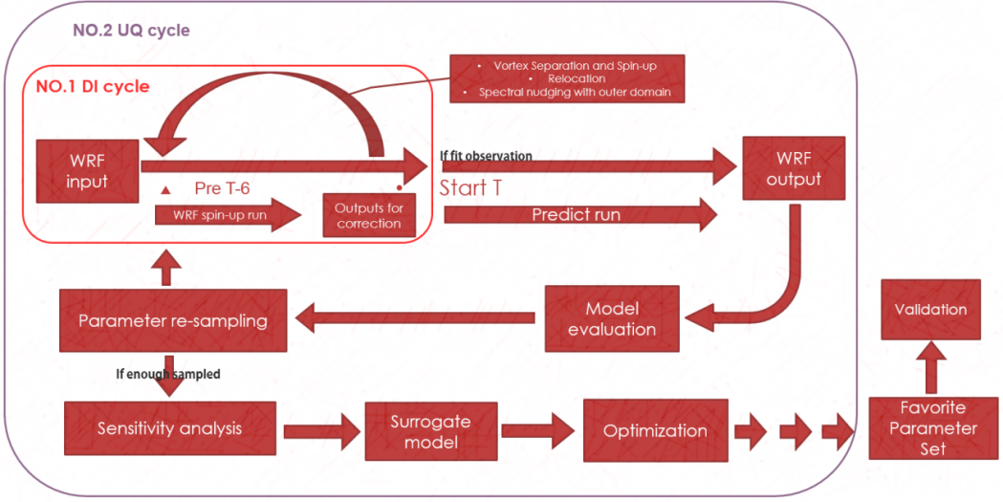

Fig2. Sketch of routine integrating DI&UQ

As illuminated above in Fig2, a WRF prediction run is expanded with two major cycles. Specifically, we adapt inner DI cycle letting the model start 6-hour beforehand previous the forecast period (called WRF spin-up run in fig) to judge whether the simulation is robust and reliable for further prediction by comparing “features” (refers to typhoon vortex location, pressure, wind speed etc.) with observations given in external files. If these features are poorly consistent, this process will keep cycling over time, gradually fill the gap of between prediction and observation until mismatch is within an acceptable range.

Then UQ cycle started to do following 3-day forecast. This time system cycles through different parameter sets: each time a prediction is done, all 23 parameters chosen from WRF schemes will be re-sampled and renewed automatically in model code. The downstream steps after are as depicted earlier in methodology part.

The combination of DI and UQ architecture works like a “double insurance” to model simulation: Correct state at beginning, and restrain model behavior alongside.

## Results

To prepare a lower dimension optimization cutting down computation costs, we first committed sensitivity analysis to 23 parameters with 250 model run. As mentioned before, the sensitivity experiments were conducted on different proposed objectives (view in List2) using different SA methods including including multivariate adaptive regression spline (MARS), sum of tree (SOT), delta-test (DT) and surrogate-based Sobol. Below Fig3 shows the result of parameters’ sensitivity over different objectives evaluated by bunch of SA methods each. Our proposed objectives are categorized into three types: rainfall related type (total precipitation amount, TS, rainfall MAE etc.), pressure related type (determination coefficient, MAE and RMSE) and wind-speed (Beaufort 10 scale wind radius, determination coefficient, MAE and RMSE) related type. The bottom row sums all importance together computing cumulative significance S as in detailed in (1).

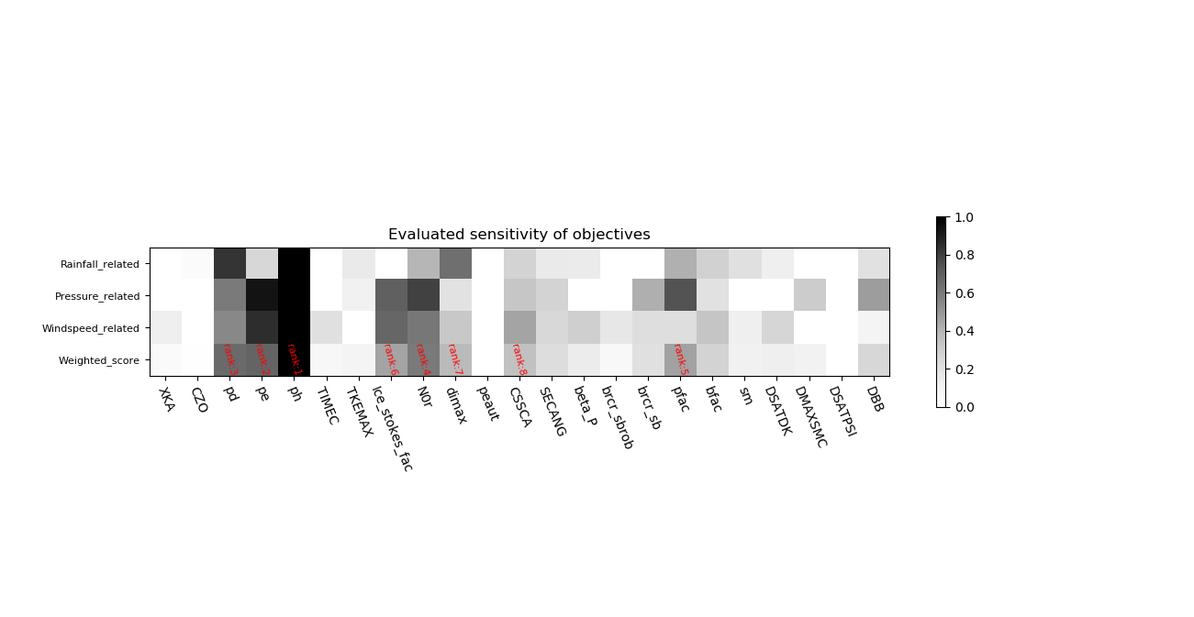

*Fig3. Sensitivity result of 23 parameters*

Parameters’ sensitivity score in above fig are rearrange between range 0 and 1 each row, where 1 represents the most sensitive and 0 the least. Some common features are showed: 1)Despite the different kind objectives we use, some same parameter are always tend to be more sensitive than others. Like parameter No.3 (pd) No.4(pe) and No.5 (ph), their blocks are dyed deeper all the time, which makes them three ranked top sensitive when we consider all objective in last row. 2)Some parameters like No.2 (CZO), No.11 (peaut) and No.22 (DSATPSI) are seemed negligible to any results of concerned functions, thus if we are worrying about high-dimensional issue, they are the first ones that we could choose to get rid of. It’s also noticeable and reasonable that some key parameters indicate by rainfall-related function differ from those given by pressure of speed related function----like parameter No,4, No.7 and No.8, which are all sensitive when judging with functions from row two and row three, but less sensitive as is evaluated by first row.

With following optimization, we consider mean score of all objectives computed as (1)(last row in above fig) to give out their final rank. In our experiment, we take threshold of 70% uncertainty contribution to do the screen out. Altogether 8 parameters are chosen: they are parameter number 5,4,3,9,17,8,10,12 (sorted from most sensitive).

ASMO optimization usually starts with a surrogate model to minimize its cost function. Employing above 8 parameters, we conduct 200 sample run to build this surrogate. Then from loop time 200, algorithm starts to search optimum. The value of objective function we use is Z-score normalized with four objective: 1)6-hourly precipitation amount error, 2)-TS, 3)center pressure error and 4)maximum speed error as depicted earlier in (2). Fig4 below shows real optimization process together with default value, which is also evaluated by (2) and colored red in dash. The coarser lower curve in blue stands for global minimum found at present.

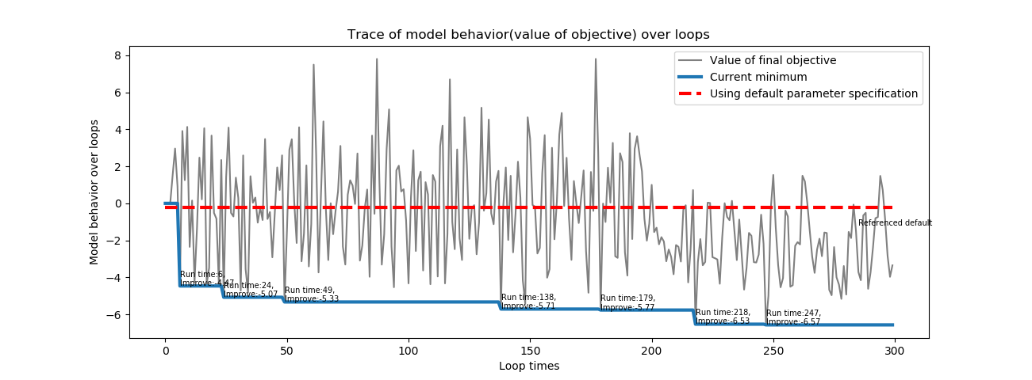

*Fig4. Trace of model value over optimization*

As portrayed above in Fig4, for first 200 loop, the algorithm walk randomly causing value of objective “zipzag” to optimize or worsen (below or above default red dash) the model. When it starts to search optimum, this value tend to go down indicating that there’s less error in model output, only with few times worsen the model. This pattern of model action implies the algorithm is functioning good. It shows that in loop time of 218 a new optimum point in reached with cost function value of -6.51. Yet we can say that this is not an easy task for another 30 loops later in loop 247 this value only improves 0.06 to -6.57 and never improve anymore for last 53 run. The optimization stopped at loop 300 with minimum cost function value -6.57 at loop 247.

This optimum set of 8 dominant parameters are put up here in Fig5. This result shows that comparing to default set, besides parameter named ‘N0r’, ‘CSSCA’ and ‘Pfac’, parameters are all given a higher value. Wherein ‘Ph’ and ‘ice_stokes_fac’ are even over 2 and 1 times than default value. In contrast, parameters like ‘Pd’ , ‘N0r’ and ‘Dimax’ are only sightly tuned with couple of percentage points no more than 10%. Nevertheless it’s worth mentioned that although these parameters largely calibrated, it does not mean that the tuning of them is unnecessary. As a matter of fact, for parameters as sensitive as ‘pd’ only 1% variation of its value can end up with significant different in model results due to nonlinear effect.

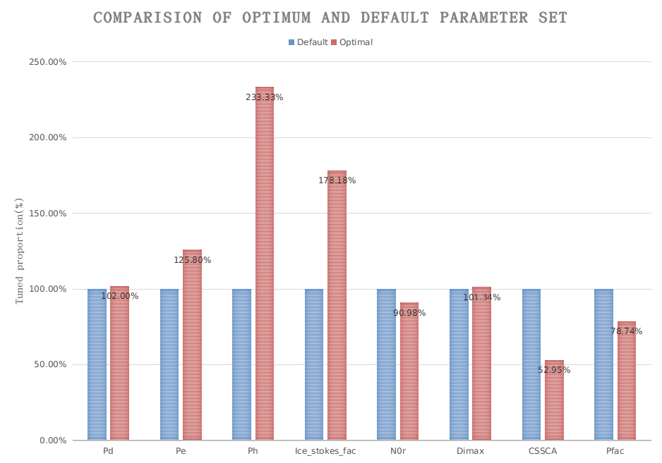

*Fig5. Trace of model value over optimization*

Finally, we redo the forecast of typhoon Rumbia with all parameter set to optimal value provided by ASMO algorithm and record its model performance improvement, list below in List4. It shows that all objectives are noticeably improved, with maximum improvement on 6-hourly MAE of center pressure----from 6.95hpa of to 5.9hpa, reaching an improvement of 15.13%. The overall improvement for this case is 9.35%.

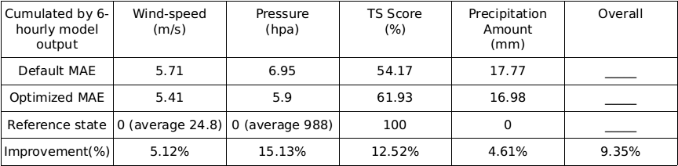

*List4. Model performance improvement*

To visualize these improved results and have a clear sight of what’s going on in model output, we have plotted group of figures to reinforce our further understanding.

In following group of figures (Fig6), we tried to shown the improvements of wind speed and typhoon center pressure over whole case period (36 hours) as listed in List4. First, variation of maximum wind speed by observation (blue), optimization (read) and default are illuminated on the left. We can see that the red curve after optimization is more closer observation curve except at hour 12, and 36 to 48 reducing MAE from 5.71m/s to 5.42m/s. Meanwhile, variation curve of typhoon center pressure on the right is more apparent of improvement: only at hour 42 and hour 66 not surmounting default, achieving 15.13% optimization from 6.95hpa to 5.9hpa MAE in average.

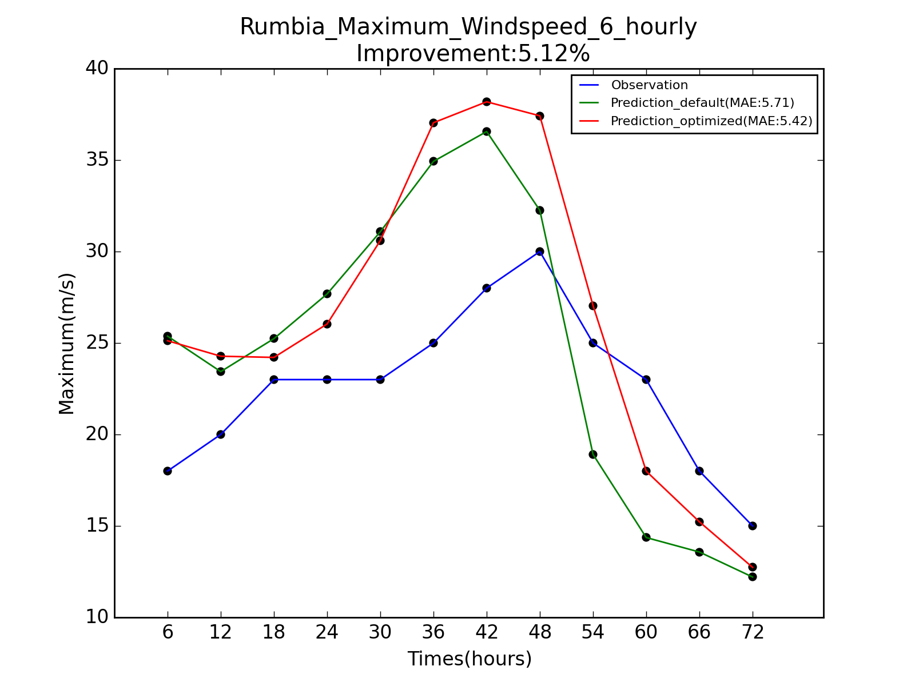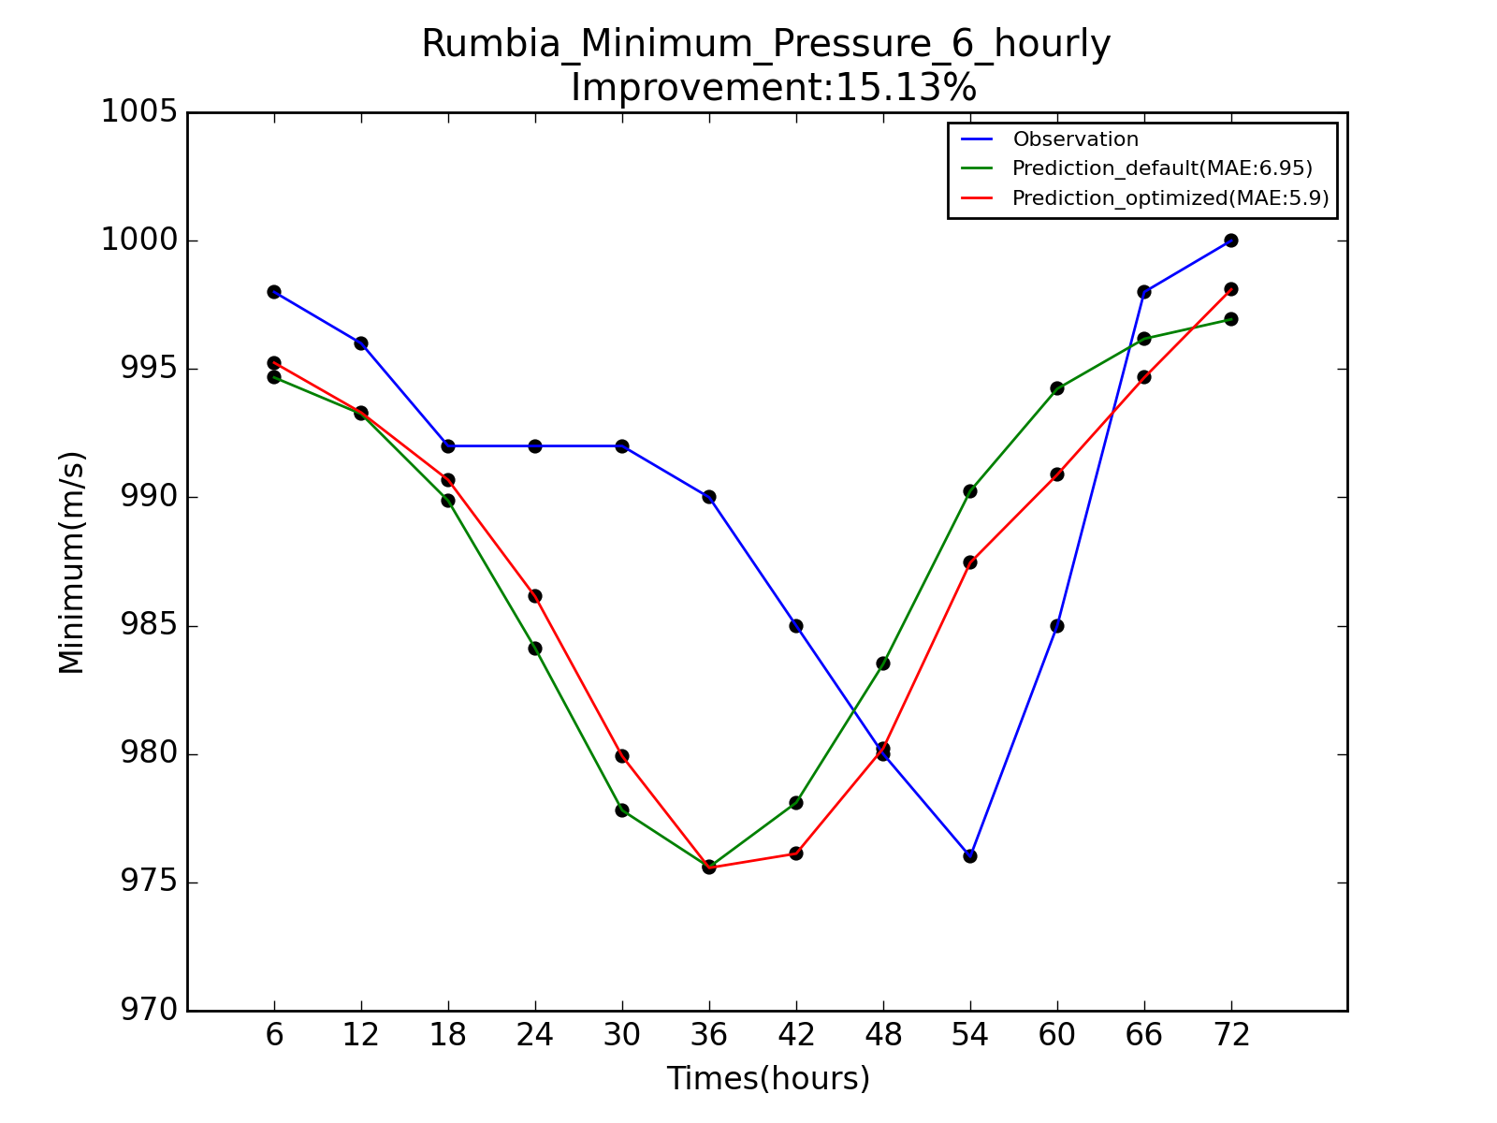

*Fig6. Comparison of forecast of maximum wind speed (left) and center pressure (right) with default*

Enhancement of TS score trigger by optimization is exhibited below in Fig7. It should be mentioned that since rainfall TS is appraised based on a set of established criterion (e.g rainfall within range of 25mm~50mm a day will be ranked as moderate rain), we thus intentionally transform precipitation amount to their corresponding rank to visualize their enhancement of ranking forecast. Color green in figure means good, suggesting a rank approximating ‘real rank’ given by observation, yet color red suggests a degradation far from reality. What we see from figure below is that most of the colored areas are green, within which there are also darker green areas indicating a two-level enhancement, especially at south-west direction. The large green-red proportion implying that TS is substantially getting better reaching an improvement of 12.52%.

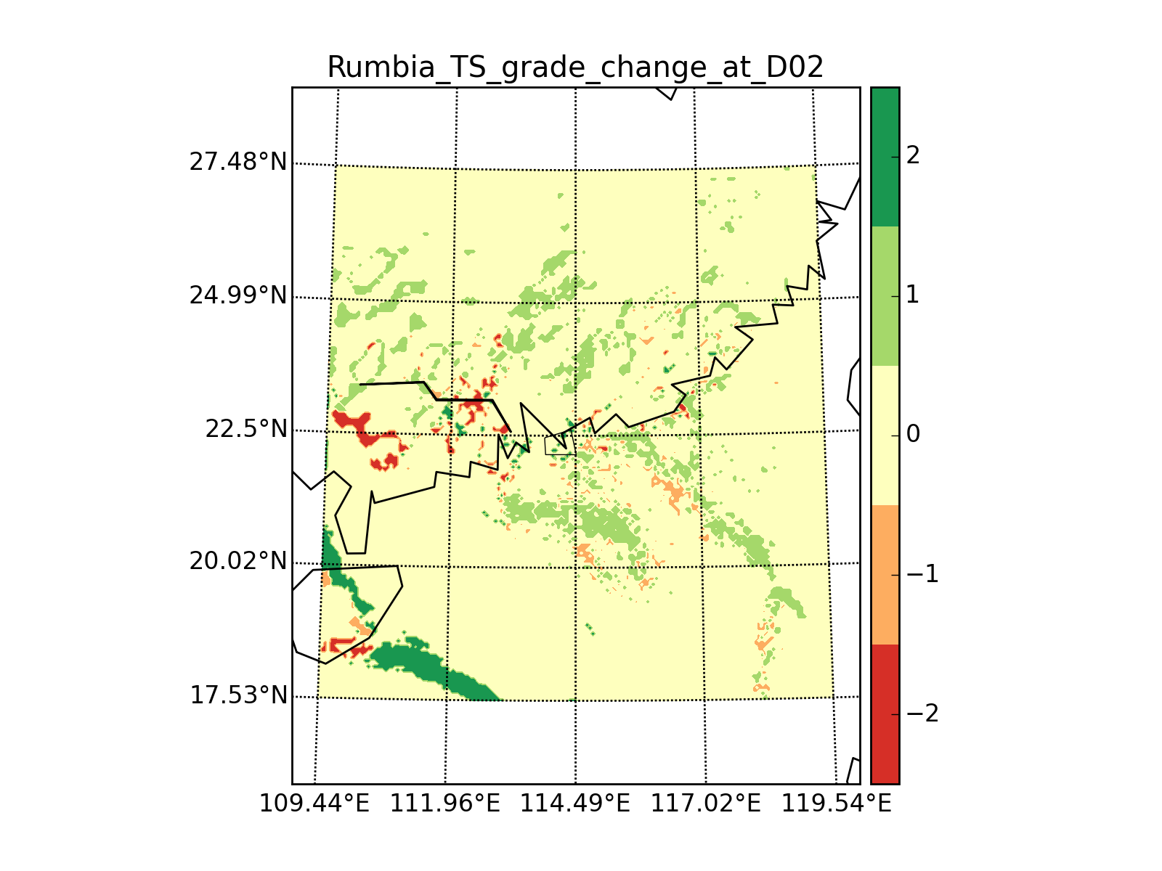

*Fig7. Alter of rainfall TS ranking*

Next, to analyze improvements on precipitation amount, we have Fig7 below in which three-day’s observed precipitation data is plotted on the left comparing with optimized precipitation in the middle and the default on the right. The first thing we notice is that no matter for optimal or default, the model always have bias producing rainfall larger than physical truth along its track. Yet middle figure have demonstrate that this bias could have been correct to some extent by optimization, for we see wherein precipitation is apparently weakened comparing to the left one. In spite of this, it’s also obvious that we can’t rectify the manner of rainfall, which have caused the too much precipitation distribution in south-east direction of Hainan island, or too concentrate to its path.

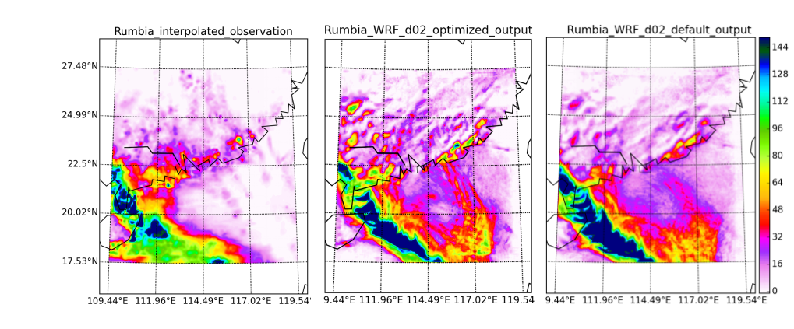

*Fig7. Three-day]s precipitation amount of interpolated observation (left), optimal model (middle), and default model (right)*

## Validation

To authenticate the accountability of optimum parameter set, we put up several verification cases. All verification cases are from same month of typhoon Rumbia also in 2013: Jebi, Utor, Trami and Kong-rey. All model settings including driving data, observation data and model warm up are identical with what we have for typhoon Rumbia listed in List3, except for simulation period and domain settings. Whereas this time, all parameters we fed the model are proposed by previous optimization result of typhoon Rumbia. The domain settings and other information of four are given in List5. In last column ‘Remarks’, we have typhoons’ category recorded, wherein TS/CATG1/CATG2 stands for Tropical Storm/Category one/Category two respectively. Note that our target case Rumbia should belongs to TS.

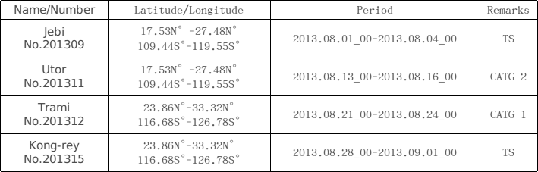

*List5. Domain settings for for verification cases*

After running forecast on these four cases, following result are given to evaluate the effect of optimal transfer (Fig8). We present model performance by objective functions evaluated. For the sake of a convenient comparison, we also present previous optimization result of case Rumbia (see *List4*) on the first one left. We see that the cases of Jebi, Utor and Kong-rey have all outperformed than default when forecasting typhoon, with average improvement of 8.53%, 2.01% and 6.99% respectively. We are surprise to find that Jebi have most tangible improvement of 8.53% which is even comparable to what we have for target case 9.35%. We speculate that this is because Jebi has the same category of TS to our target case Rumbia. This [conjecture](http://dict.youdao.com/w/conjecture/" \l "keyfrom=E2Ctranslation) can also be backed by Kong-rey case, indicating that our optimum solution have great potential generalizing over typhoon events that has similar intensity. In contrast, for Utor and Trami of category CATG2 and CATG1, it’s much harder for model to perform very good---Utor forecast was only improved by 2.01%, yet objectives of Trami have been sightly worsen.

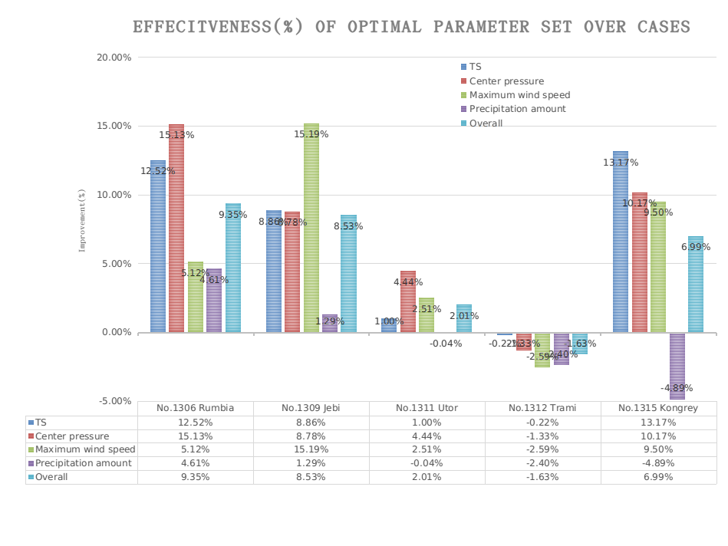

*Fig8. Validation results of four cases to optimal*

## Conclusion

An accurate prediction of the motion and intensity of a typhoon is critical to preparedness and evacuation for areas that could potentially be hit by an intense typhoon. A correct parameter specification would contribute to it. In this study, twenty-three WRF model parameters’ sensitivity are evaluated by their influence exerting on simulation of precipitation, pressure and wind speed after the model is warmed-up in initialization. The tuning of dominative parameters have reduced the dimension of the problem and greatly cut down computing costs in optimization. It’s truly valuable, that for large complex dynamic models like WRF, have this kind of procedure done in the advance before calibration or optimization every now and then.

Since this typhoon event took place in exactly same area as our previous studied Rumbia, we expect tuned model parameters may fit better for this event as well comparing the default.

Only one time the model performance is slightly undermined while others have all showed handsome improvement. If we factor in ... We can say is good.

For errors that can’t be eradicated by parameter calibration due to model limitation, we can only count on future model structure improvement to fix them.

This research work provides a reliable solution improving the efficiency and effectiveness for typhoon forecast using large complex model like WRF. At the same time, since we have followed suit in relevant model settings with typhoon real-time forecasting center in China, it could perform as a valuable guidance for business departments to improve their quality of the forecast and potential for reducing loses of extreme typhoon events.

## References

Almanac article: Fact Monster.© 2000–2013 Sandbox Networks, Inc., publishing as Fact Monster.01 Nov. 2016 http://www.factmonster.com/ipka/A0775896.html

Recent studies on tropical cyclone land falling in China; Lei Xiaotu, Shanghai Typhoon Institute CMA, Shanghai, China

Wang, C.F. & Li, X. &Chen, Y.T (etc), 2012. CMA satellite broadcasting system design. Journal of Applied Meteorological Science 23(1):113-120

Duan, Q., Z. Di, J. Quan, C. Wang, W. Gong, Y. Gan, A. Ye, C. Miao, S. Miao, X.Liang, and S. Fan, 2016: Automatic model calibration - a new way to improve numerical weather forecasting. Bull. Amer. Meteor. Soc. doi: 10.1175/BAMS-D-15-00104.1, in press.

海洋学报Acta Oceanologica Sinica,Vol.2008.04 Zhang Qing-hong1, GUO Chun-rui 1 Department of Atmospheric Science, School of Physics, Peking University, Beijing, China

Chun-Chieh Wu, Morris A. Bender and Yoshio Kuriharal, Typhoon Forecast with the GFDL Hurricane Model: Forecast Skill and Comparison of Predictions- using AVN and NOGAPS Global Analyses, Journal 01 Meteorological Society 01 Japan, Vol. 78, No.6, pp. 777-788, 2000

Duan, Q., Schaake, J., Andreassian, V., Franks, S., Goteti, G., Gupta, H.V., Gusev, Y.M.,Habets, F., Hall, A., Hay, L., Hogue, T., Huang, M., Leavesley, G., Liang, X.,Nasonova, O.N., Noilhan, J., Oudin, L., Sorooshian, S., Wagener, T., Wood, E.F.,2006. Model parameter estimation experiment (MOPEX): an overview of science strategy and major results from the second and third workshops. J. Hydrol.320 (1e2), 3e17.

Emanuel, K. A., 2003: Asimilarity hypothesis for air–sea exchange at extreme wind speeds. J. Atmos. Sci., 60, 1420–1428.

Moon, I.-J., I. Ginis, and T. Hara, 2004: Effect of surface waves on Charnock coefficient under tropical cyclones. Geophys. Res. Lett., 31, L20302, doi:10.1029/2004GL020988

Davis, C., and Coauthors, 2008: Prediction of landfalling hurricanes with the Advanced Hurricane WRF model. Mon. Wea. Rev., 136, 1990–2005.

Ma, L.-M., and Z.-M. Tan, 2009: Improving the behavior of the cumulus parameterization for tropical cyclone prediction: Convection trigger. Atmos. Res., 92, 190–211.

Chen, S. S., J. F. Price, W. Zhao, M. A. Donelan, and E. J. Walsh, 2007: The CBLAST-Hurricane Program and the next-generation fully coupled atmosphere–wave–ocean models for hurricane research and prediction. Bull. Amer. Meteor. Soc., 88, 311–317

Ueno, M., 1989: Operational bogussing and numerical prediction of typhoon in JMA. JMA/NPD Tech. Rep. 28, 48 pp.

George, J. S., and R. A. Jeffries, 1994: Assimilation of synthetic tropical cyclone observations into the Navy Operational Global Atmospheric Prediction System. Wea. Forecasting, 9, 557–576.

Zou, X., and Q. Xiao, 2000: Studies on the initialization and simulation of a mature hurricane using a variational bogus data assimilation scheme. J. Atmos. Sci., 57, 836–860]

Davidson,N.E., andH.C.Weber, 2000: TheBMRChigh-resolution tropical cyclone prediction system: typhoon-LAPS. Mon. Wea. Rev., 128, 1245–1265.

Kurihara, Y., M. A. Bender, and R. J. Ross, 1993: An initialization scheme of hurricane models by vortex specification. Mon. Wea. Rev., 121, 2030–2045.

Hendricks, E. A., M. S. Peng, X. Ge, and T. Li, 2011: Performance of a dynamic initialization scheme in the Coupled Ocean–Atmosphere Mesoscale Prediction System for Tropical Cyclones (COAMPS-typhoon). Wea. Forecasting, 26, 650–663.

Nguyen, H. V., and Y.-L. Chen, 2011: High-resolution initialization and simulations of Typhoon Morakot (2009). Mon. Wea. Rev.,139, 1463–1491.

A GUI platform for uncertainty quantification of complex dynamical models,2015,Chen Wang, QingYun Duan, Environmental Modelling & Software 76 (2016) 1e12

Duan, Q.Y., Sorooshian, S., Gupta, V., 1992. Effective and efficient global optimization for conceptual rainfall-runoff models. Water Resour. Res. 28 (4), 1015e1031.

Aerosol-Cloud-Precipitation Interactions in WRF Model:Sensitivity to Autoconversion Parameterization, Journal of Meteorological Research,2015,(01):72-81.

Yang B, Qian Y, Lin G, et al. Some issues in uncertainty quantification and parameter tuning: a case study of convective parameterization scheme in the WRF regional climate model[J]. Atmospheric Chemistry & Physics, 2012, 12(5):2409-2427.

Di Z, Duan Q, Wei G, et al. Assessing WRF model parameter sensitivity: A case study with 5 day summer precipitation forecasting in the Greater Beijing Area[J]. Geophysical Research Letters, 2015, 42(2):579-587.

Dong-Hyun Cha and Yuqing Wang, A Dynamical Initialization Scheme for Real-Time Forecasts of Tropical Cyclones Using the WRF Model, MONTHLY WEATHER REVIEW VOLUME 141 DOI: 10.1175/ 2012.

Improving Simulation of a Tropical Cyclone Using Dynamical Initialization and Large-Scale Spectral Nudging: A Case Study of Typhoon Megi，2013，WANG Hui1, WANG Yuqing, and XU Haiming

Recent studies on tropical cyclone land falling in China Lei Xiaotu, Shanghai Typhoon Institute CMA, Shanghai, China

Saltelli, A. (2002). Making best use of model valuations to compute sensitivity indices. Computer Physics Communications 145, 280–297.

A GUI platform for uncertainty quantification of complex dynamical models,2015,Chen Wang, QingYun Duan, Environmental Modelling & Software 76 (2016) 1e12

Efficient Global Optimization for Conceptual Rainfall-Runoff Models, QINGYUND UAN, SOROOSSHO ROOSHIAANN, D VIJAI GUPTA, WATERR ESOURCESR ESEARCHV, VOL. 28,N O. 4, PAGES1 015-103A1, 1992

Assessing WRF model parameter sensitivity: A case study with 5 day summer precipitation forecasting in the Greater Beijing Area, 2014, Zhenhua Di

Global Sensitivity Analysis: The Primer, SALTELLI, A., RATTO, M., ANDRES, T., CAMPOLONGO, F., CARIBONI, J., GATELLI, D., SAISANA, M., and TARANTOLA, S, Biometrics 65(4): 1311-1312, December 2009, DOI: 10.1111/j. 1541-0420. 2009. 01343_7.x]

Assessing parameter importance of the Common Land Model based on qualitative and quantitative sensitivity analysis, J.Li, Q.Y.Duan, Hess, doi: 10.5194/hess 17-3279-2013

Multi-objective parameter optimization of common land model using adaptive surrogate modeling,W. Gong, Q. Duan, HESS, 2015

DDS: an efficient dynamic dimension selection algorithm for nearest neighbor search in high dimensions, Conference Paper, July 2004, DOI:10.1109/ICME.2004.1394371. Source: IEEE Xplore. Conference: Multimedia and Expo, 2004. ICME ’04. 2004 IEEE International Conference on, Volume:2

Gong Wei&Qingyun Duan, Multi-objective adaptive surrogate modeling-based optimization for parameter estimation of large, complex geophysical model, Water Resources Research, DOI: 10.1002/2015WR018230

## Appendix:

###### Dynamical Initialization scheme

Model warm up like data assimilation is worthwhile for numerical weather prediction (NWP) models to gain more accuracy in initial conditions. Different method may end up with slightly different model state. Considering to be accordant with CMA operational settings to be set for possible future operational guiding significance, we use Dynamical Initialization (DI) module approved by CMA which has also been proved effective. A rough view of DI scheme is portrayed below in Fig9. It consists of four main procedures in model pre-run period: 1) separation of a typhoon vortex; 2) repeated cycle runs for typhoon vortex spin up; 3) spectral nudging to reduce bias in large-scale fields in the cycle runs, and 4) relocation of the spun up typhoon vortex to the observed position.

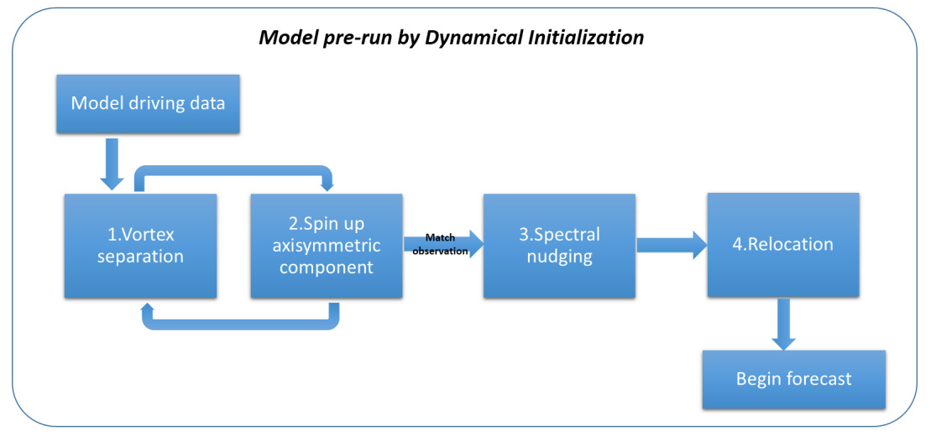

*Fig9. General view of major steps in DI*

In step 1, Kurihara vortex separation method is proposed in DI scheme to enhance the vortex component, which is the main purpose in spinning up. Because the vortex component in real typhoon is not necessarily circular, while minimizing the removal of important non-hurricane features, it uses a filtering method to obtain the vortex component. In step 2, cycle runs are repeated by WRF model runs conducting a 6-h window before forecast time. Literally this cycle process, embedded the generated axisymmetric vortex component from last run to the next run until simulation approximate to observation. In step 3, by the act of spectral nudging, we try to eliminate possible nontrivial error in the environmental field at initial forecast time against the model driving data. Finally in step 4, DI scheme utilizes a relocation method that is similar to Hsiao et al. (2010), to avoid a non-negligible position error in its center. [Dong-Hyun Cha and Yuqing Wang, A Dynamical Initialization Scheme for Real-Time Forecasts of Tropical Cyclones Using the WRF Model, MONTHLY WEATHER REVIEW VOLUME 141 DOI: 10.1175/ 2012]

Other than fill the gap between observation and prediction, during spin up spectral nudging (SN) is used to keep the environmental information close to the observations as well as to retain motions with wavelengths longer than 1000km, this allows the typhoon vortex to better adapt to the environment and to achieve the dynamical balance sufficiently. At the same time relocation will happen if the vortex position is not close enough to where it has actually been monitored [Improving Simulation of a Tropical Cyclone Using Dynamical Initialization and Large-Scale Spectral Nudging: A Case Study of Typhoon Megi，2013，WANG Hui1, WANG Yuqing, and XU Haiming].